EXP NO:06 DATE:
DESIGN AND SIMULATION OF TEMPERATURE SENSOR CIRCUIT USING KICAD
AIM

To design and simulate a temperature sensing alarm circuit using an NTC thermistor and BC547 transistors, and observe the buzzer response for different temperature conditions using KICAD software

SOFTWARE REQUIRED

- KiCAD software

COMPONENTS REQUIRED

S.No. | Component | Value/Specification
1 | Thermistor (NTC) | 1 kΩ
2 | Potentiometer | 10 kΩ
3 | Transistor Q1 | BC547
4 | Transistor Q2 | BC547
5 | Buzzer | 5 V
6 | DC Supply | 5 V

THEORY
A temperature sensor like the LM35 provides an analog voltage proportional to the ambient temperature. The relationship for LM35 is:
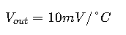
The sensor output can be fed to an ADC (Analog to Digital Converter) of a microcontroller to obtain a digital temperature reading.
CIRCUIT DESIGN
- Sensor Connection:
  - Connect VCC to 5V (or 3.3V).
  - Connect GND to Ground.
  - Connect the VOUT of LM35 to an ADC pin of the microcontroller.
- Signal Conditioning (if needed):
  - Use an Op-Amp (IC741) as a buffer to stabilize the signal.
  - A low-pass filter (RC circuit) can be added to remove noise.
- Microcontroller Processing:
Read the analog voltage from the sensor.
Convert to temperature using:
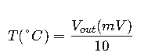
  - Display the temperature on an LCD or Serial Monitor.
Circuit Principle
- The NTC thermistor senses temperature.
- Its resistance decreases when temperature increases.
- The thermistor and potentiometer form a voltage-divider circuit.
- Q1 and Q2 (BC547) provide switching/amplification.
- When the sensed temperature crosses the preset threshold, the transistor stages activate the buzzer.
- The potentiometer is used to adjust the temperature threshold.

CIRCUIT DIAGRAM :

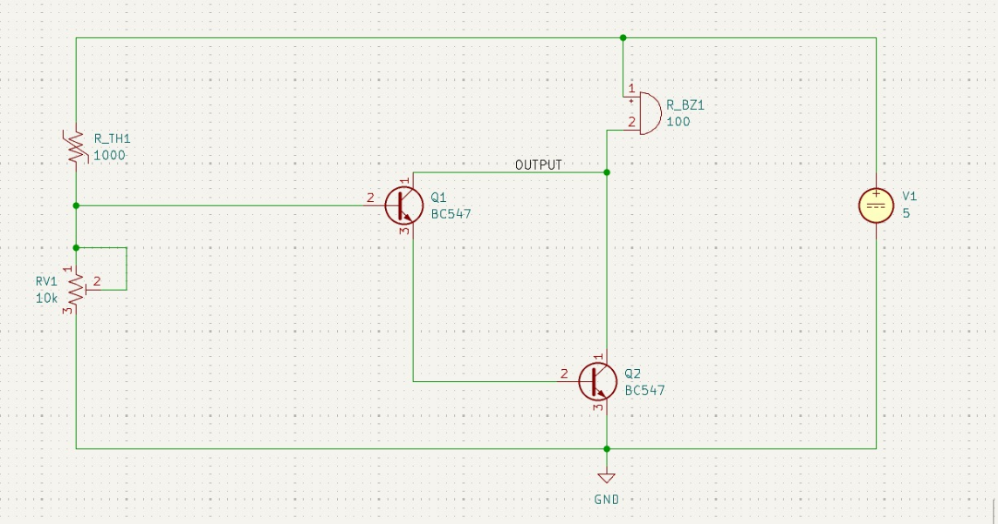
Waveforms :

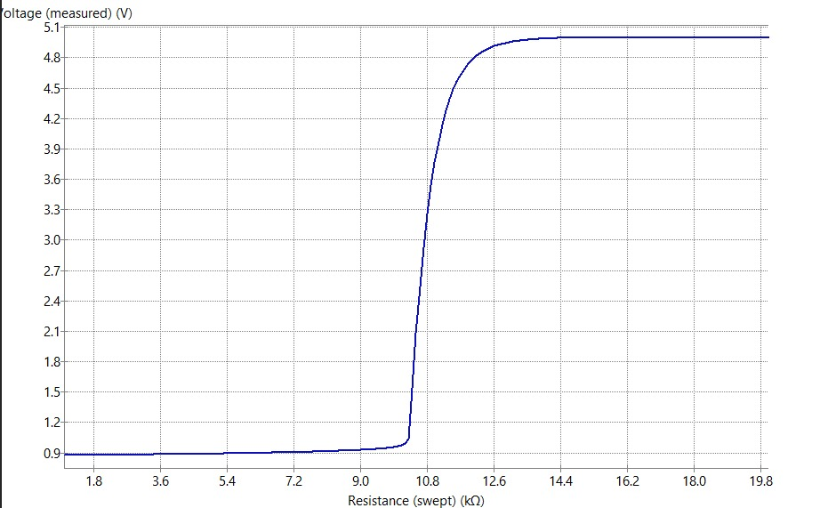

PROCEDURE
- Connect the circuit as shown in the given diagram.
- Apply a 5 V DC supply.
- Set the potentiometer to the desired threshold.
- Vary the temperature around the thermistor.
- Observe the voltage at the OUTPUT node.
- Note whether the buzzer is ON or OFF for different thermistor resistance/temperature conditions.
- Record the observations in the table.

RESULT
Thus the temperature sensor circuit to display the output on an LCD was designed and simulated and the PCB for the circuit was created.

